FACE RECOGNIZATION ATTENDENCE SYSTEM

1. REQUIREMENTS
   1. Image datasets
   2. NumPy
   3. Pandas
   4. OpenCV-python
   5. Deep learning
   6. Image compression
   7. sk-learn
   8. tensor flow
2. APPROACH

Capturing the image(face) in continuous video. The captured face in RGB will be converted into GRAY SCALE (which is used to process image efficiently).

Then captured image will be compressed for further processing. The compressed image will be compared with given datasets.

If the image is found the attendance will be updated in the database. Otherwise, user will update the image into dataset.

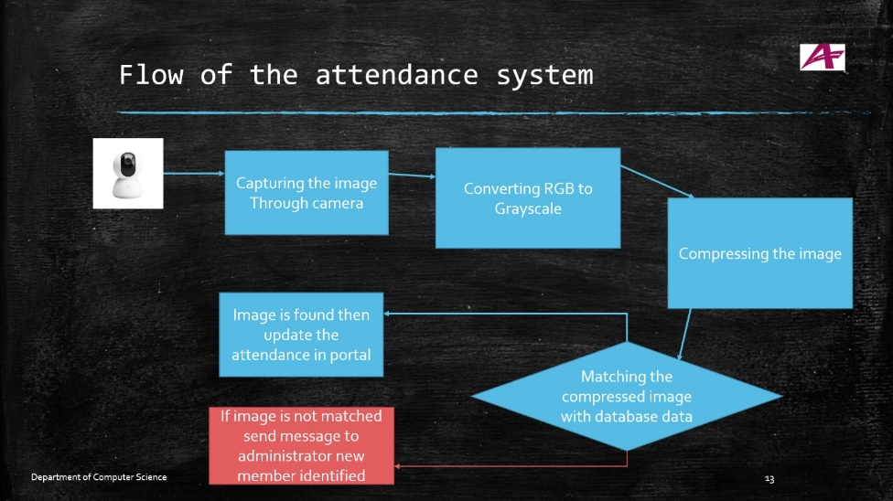CAPTURED IMAGE -> CONVERTED INTO GRAY SCALE IMAGE->IMAGE COMPRESSION TECHNIQUE-> COMPARED WITH DATASET IMAGES->IF IMAGE IS FOUND THEN UPDATE THE DATABASE WITH ATTADENCE

Which is used to convert color image to gray scale image

And image will be

import numpy as np  
import cv2  
import scipy  
img=cv2.imread("p.jpg")  
#print(img)  
cv2.imshow("img",img)  
gray1=cv2.cvtColor(img,cv2.COLOR_BGR2GRAY)  
img_as_np = np.asarray(gray1)  
print(img_as_np)  
print(img_as_np.mean())  
cv2.imshow("gray1",gray1)  
  
cv2.waitKey(0)

Day 1:

Camera

Import cv2

Cap=cv2.vediocapture(0)

While(true):

Retr,frame=cap.read()

Gray=cv2.cvtColor(frame,cv2.COLOR_BGR2GRAY)

Cv2.imshow(‘frame’,gray)

If cv2.waitKey(1) & 0xFF==ord(‘q’): 1sec=1000milisecond

Break

Cap.release()

Cv2.destoryAllWindows()